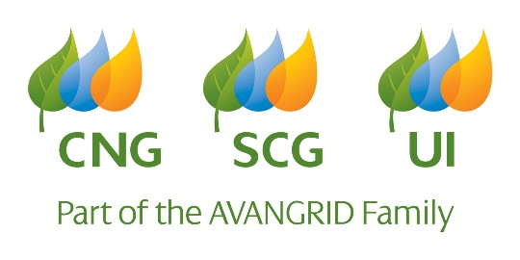

**2022 Economic Development Application for Financial Support**

Today’s Date:

Name of Organization:

Address of Organization:

Organization’s Website Address:

Name and title of contact person for this application:

Telephone & e-mail:

Yes  No

Click here to enter text.

Type of support requested: Grant Support Sponsorship Other (describe below)

Click here to enter text.

Mission and Objectives of your Organization: (Please include geographic area served)

Click or tap here to enter text.

Amount Requested:

Purpose of Support:

* What is the desired outcome as a result of the funding?

Click here to enter text.

* Who will be the main beneficiaries of the support?

Click here to enter text.

Please check the Avangrid core objectives your project meets:

Business Development Workforce Development Brownfield/Redevelopment

Entrepreneurial Activities Educational Programs

Please explain how the project meets the above selection

Click here to enter text.

What can we expect from this support? (Recognition, sponsorship benefits, tickets, branding opportunities, etc.)

Click here to enter text.

Please provide the following documents when submitting your request:

* Copy of your IRS determination letter indicating exempt status or current W-9 form
* Most recent annual report

Click here to enter text.

Please send completed applications to:

[fundingrequests@uinet.com](mailto:fundingrequests@uinet.com)

60 Marsh Hill Rd., 2nd Floor, Orange, CT 06477